 | 
  

Through the

Poet's Eye

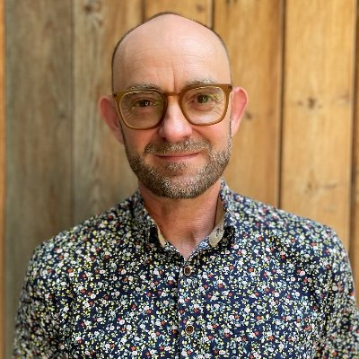

﻿Poet Chris Hutchinson: Seedwork

Chris Hutchinson is the author of five poetry collections—most recently Lost Signal (Palimpsest Press, 2025)—and the autofictive verse novel Jonas in Frames (Goose Lane Editions). He has knocked around, studied, and taught all over North America, from Dawson City, YT to Brooklyn, NY. Chris currently teaches creative writing at MacEwan University.

By Chris Hutchinson

I learn by going where I have to go. —Theodore Roethke, “The Waking”

I’ve never had an idea or an outline for a poem, or a book of poems, in my life. I guess that puts me at odds with the so-called conceptual artists, the dramatists and narrative writers of causally linked events, and the poets who research and build out from a single governing question. This isn’t a virtue, however. I often wish I could plan ahead—scheme, design.

Even now, writing this little essay, I have no idea where I’m going. I’m just digging around, groping towards a seed-sized flicker of intuition growing somewhere in the dark.

Another way to say this is: I’m a gardener, not an architect. I lifted this tidbit from playwright Beth Graham, whom I met during her tenure as Writer in Residence at MacEwan University last fall. I was asking her about plot—my perennial weakness whenever I attempt narrative. I had assumed that, being a dramatist, she would hand me a blueprint, or a roadmap, or a series of twelve stages or steps to follow. Instead, she paraphrased George R. R. Martin (aka G.R.R.M., the novelist behind Game of Thrones), who said that some writers are architects who “plan everything ahead of time,” blueprinting the whole structure before “nailing the first board,” while others “drop in a seed and water it,” knowing roughly what they’ve planted, but only discovering the shapes of the branches and leaves as they grow. Like Beth, G.R.R.M. considers himself “much more a gardener than an architect.” And so do I.

I find this comforting. There are others out there like me. Sure, architects are noble creatures, but gardeners have their own kind of charm, even as most of our work unfurls in the fecund dark. It was a relief to realize that even playwrights and novelists—writers I had assumed depended on rigid narrative frameworks—can trust in a kind of unwritten almanac of seasonal and emotional weather to carry their work to fruition.

And anyway, I’ve always liked dwelling in a state of “not knowing,” in what Keats called “negative capability . . . being in uncertainties, mysteries, doubts, without any irritable reaching after fact and reason.” I enjoy getting lost in the understory, only to stumble upon a new path to the river valley—a path my readers might vicariously discover, too. And I like not knowing what
a poem is—what it should say or do—or even how to write one. If I knew how to write a poem I’d stop writing poems, if you know what I mean.

Yes, it’s more fun to relinquish control, abandon all expectations, and let the language emerge “as naturally as the leaves to a tree” (Keats again). Never mind the literary critics, prize jurors, and my own internal editors peering over my shoulder, toxically scrutinizing.

I say, let each new poem start without any awareness of itself, or its audience, or its author, or its future unfolding. Let it begin with a seed of intuition working upward through the dark toward a light it doesn’t yet recognize. Trust that the first line, the first word, the first inkling of a syllable carries within itself its own purpose and design—not just information, but the very tools and instructions for how to grow.

Listen to Chris Hutchinson in conversation with poet Marco Melfi, author of Routine Maintenance and member of the Edmonton Poetry Festival Society Board.

